**Get Unique Values from a List Using Set Method**

Using set() property of Python, we can easily check for the unique values. Insert the values of the list in a set. Set only stores a value once even if it is inserted more than once. After inserting all the values in the set by list_set=set(list1), convert this set to a list to print it.

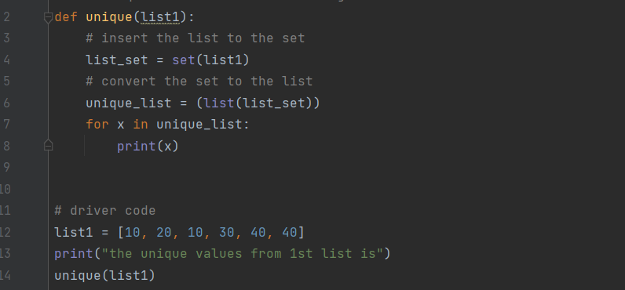

**Output:**

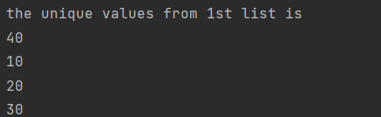

**Get Unique Values From a List in Python Using reduce() function**

Using Python import reduce() from functools and iterate over all element and checks if the element is a duplicate or unique value. Below is the implementation of the above approach.

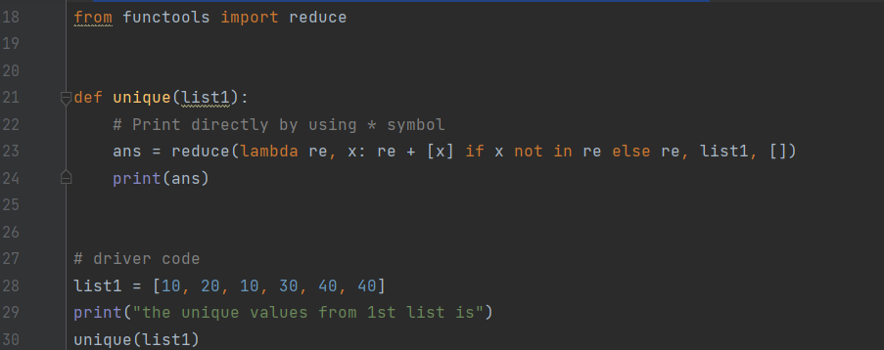

**Output:**



**Get Unique Values From a List in Python Using Operator.countOf() method**

The ‘unique’ function initializes an empty ‘unique_list’, then iterates through ‘list1’. For each element ‘x’, it employs ‘op.countOf()‘ to check if ‘x’ is present in ‘unique_list’. If not found (count is 0), ‘x’ is appended to ‘unique_list’. The final unique values are printed using a loop. The driver code demonstrates this process for two lists, ‘list1’ and ‘list2’, showcasing the extraction of distinct elements from each list while maintaining their original order.

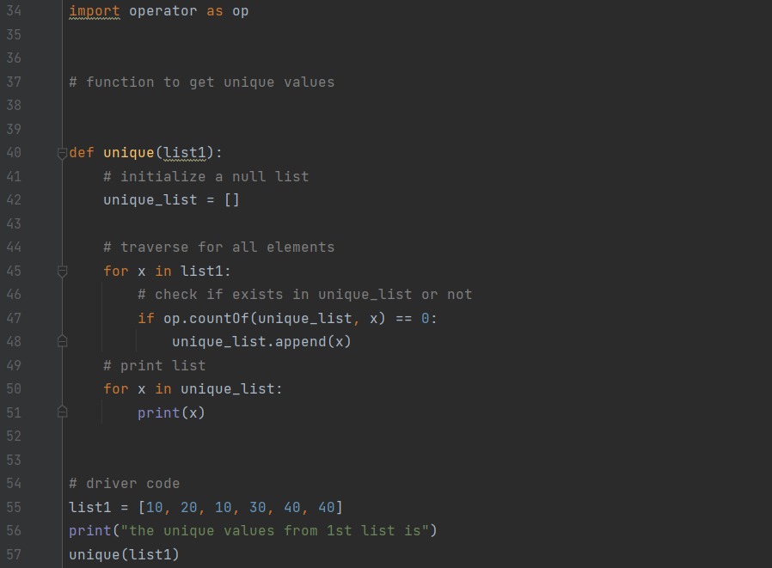

**Output:**

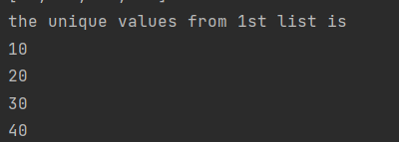

**Get Unique Values From a List in Python Using pandas module**

The ‘unique’ function utilizes Pandas to create a Series from ‘list1’, then employs ‘drop_duplicates()’ to eliminate duplicates and obtain a list of unique values. Subsequently, it iterates through the unique list and prints each element. The driver code demonstrates the process for two lists, ‘list1’ and ‘list2’, providing distinct values for each list.

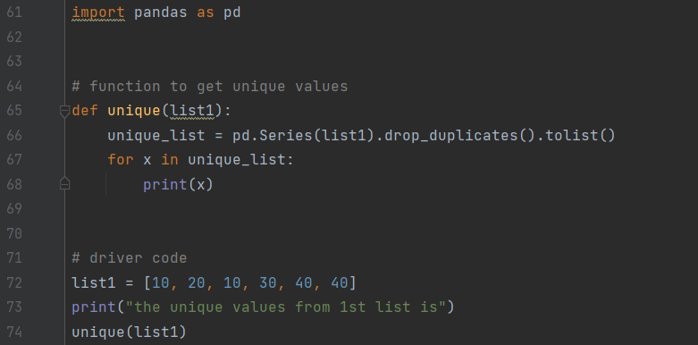

**Output:**

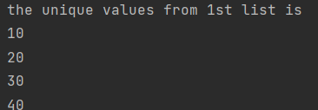

**Get Unique Values From a List Using numpy.unique**

Using Python’s import numpy, the unique elements in the array are also obtained. In the first step convert the list to x=numpy.array(list) and then use numpy.unique(x) function to get the unique values from the list. numpy.unique() returns only the unique values in the list.

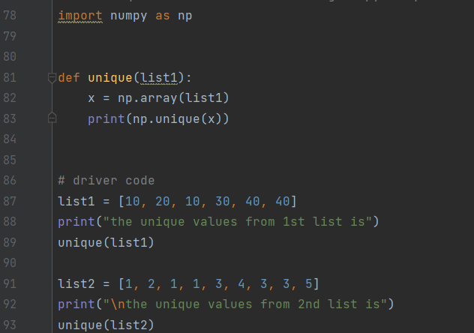

**Output:**

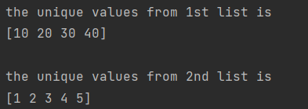

**Get Unique Values From a List in Python Using collections.Counter()**

Using Python to import Counter() from collections print all the keys of Counter elements or we print directly by using the “*” symbol. Below is the implementation of the above approach.

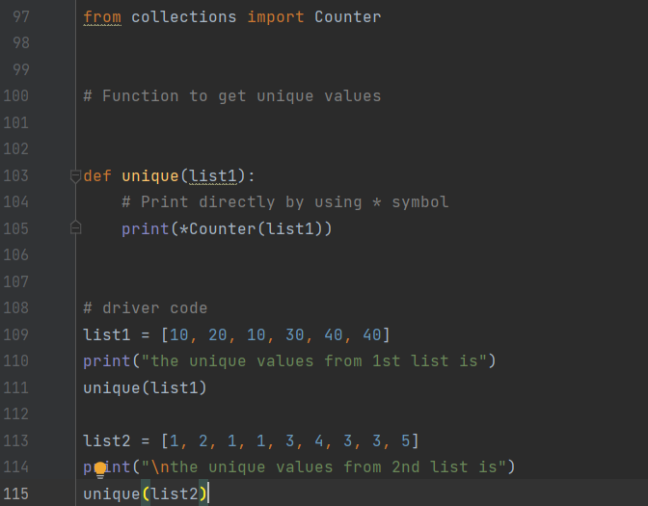

**Output:**

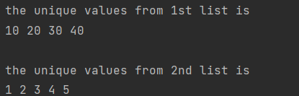

**Get Unique Values From a List Using dict.fromkeys()**

Using the fromkeys() method of dictionary data structure we can fetch the unique elements.Firstly we need to define a list that consists of duplicate elements.Then we need to use a variable in which we will store the result after using the fromkeys() method.We need to convert that result into a list, as the fromkeys() method is part of the dictionary so by default it returns a dictionary with all the unique keys and None as their values.

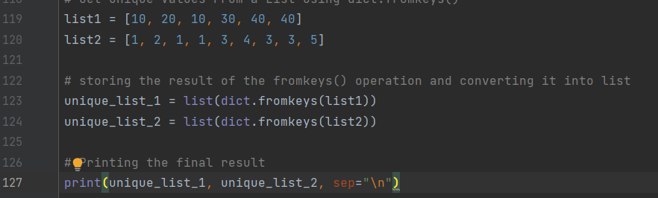

**Output:**

